Creating Transparency Using Photoshop Tools
Changing the Opacity of a Layer
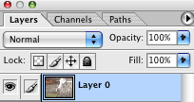
Feathering the edge of a selection
Many selection tools have a feather option field
Quick Mask Using the Gradient Tool
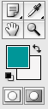
- Click on Quick Mask Mode then choose a tool to use
- Use the tool in the designed fashion
- Click back to Standard Mode
- You will see a selection (you may need to Select>Inverse to get the desired area selected)
- You can then hit delete (more than once if you need)

Lowering the Opacity of the Eraser and/or Using the Blur Tool
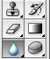

Experiment with the Layer Blend Options
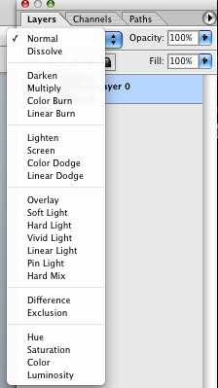
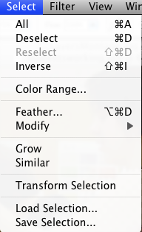
Making Modifications to a Selection

