Transforming Selected Areas of an Image

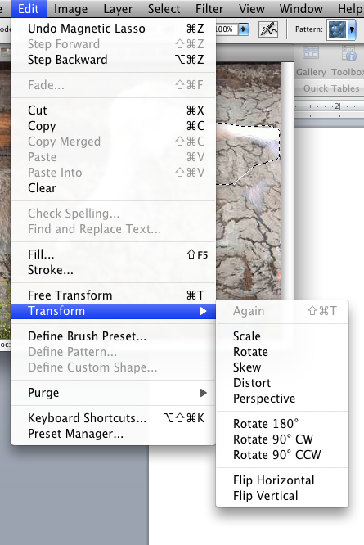
When creating an image that contains elements (objects) from a number of other images, which is called creating a photomontage, you may need to change something about your selections. Most of the alterations can be made by selecting the layer which the object is on and going to the Edit>Transform menu.

In addition to the transformations listed above you can also filter and alter the color of a selection, this will not alter the entire image, ONLY the selected area or object.

