Type Tool in Photoshop
The black/solid “T” Tools type like normal – like other applications. After you type your text you can then add interest by warping it.
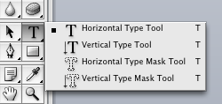

The Type Mask Tools create a mask and select the patterns and images behind the text to “fill” the text. You can then copy this text to another image and alter it.

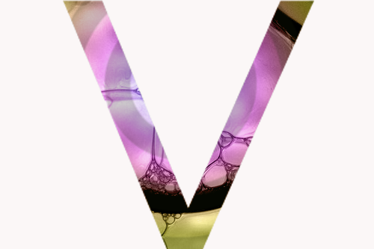
Original Image Typed a “V” with the Horizontal Type Mask Tool
Select>Inverse
Deleted everything, but the “V”

FONT Style SIZE Align COLOR

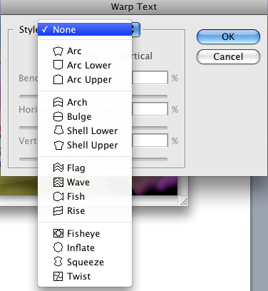

This is the Warp Text Window, it contains the shape changing options for your text. Each option has subsequent controls. You will have to play with it’s capabilities to get a good handle on what it can do.

